Logistic regression
In linear regression modeling, the outcome variable is continuous – e.g., income ~ age and education
In logistic regression, the outcome variable is categorical, and this chapter focuses on two-valued outcomes like true/false, pass/fail, or yes/no
It is basically binary classification

Explanation of Logistic Regression:
- Logistic regression is used when the target (dependent) variable is binary or categorical, like obese (1) and non-obese (0). Instead of predicting the exact value, logistic regression predicts the probability of an event (e.g., being obese).
Key Features of the Diagram:
- X-axis (Weight): The weight of individuals.
- Y-axis (Probability): The probability of being obese, ranging from 0 to 1.
- Threshold at 75 kg: This threshold seems to be the dividing point where individuals with a weight greater than 75 kg are considered obese (probability greater than 0.5), while those with a lower weight are non-obese (probability less than 0.5).
- Sigmoid Curve: This S-shaped curve represents the probability of obesity. The curve gradually transitions from non-obese to obese as weight increases.

Process in Logistic Regression:
The logistic function converts a linear regression output (which can be any value) into a probability (between 0 and 1).
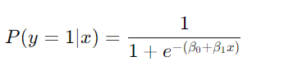
Where:
- P(y=1∣x) is the probability of being obese.
- x is the weight of the individual.
- β0, β1​ are parameters learned from the data.
- The function maps the weight to a probability of being obese
Prediction Threshold: Typically, a threshold of 0.5 is used to classify:
- Probability P(y=1∣x)>0.5: Classify as obese.
- Probability P(y=1∣x)<0.5: Classify as non-obese.
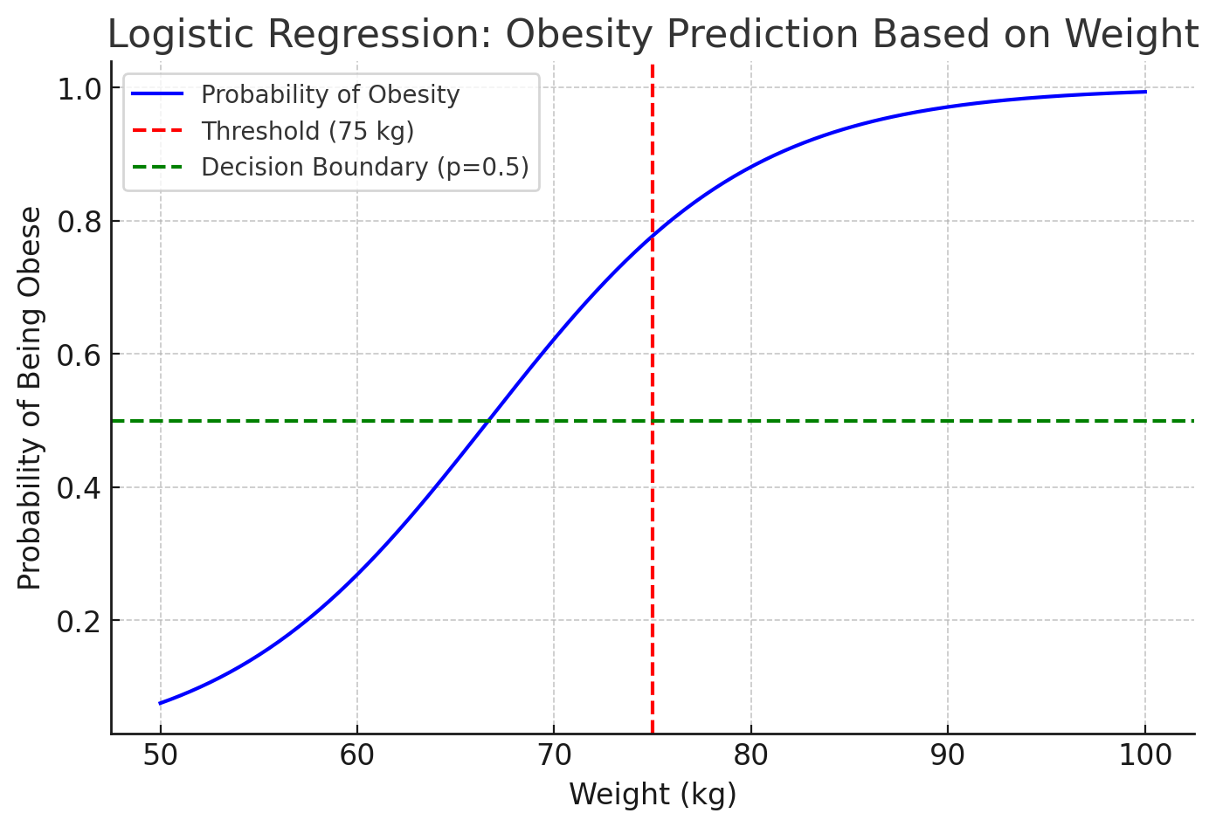
Here is a clearer version of the logistic regression graph that models the probability of being obese based on weight:
Graph Explanation:
- X-axis (Weight): Represents the weight of individuals ranging from 50 to 100 kg.
- Y-axis (Probability): Represents the probability of being obese. Values range from 0 (non-obese) to 1 (obese).
- Sigmoid Curve (Blue Line): This is the logistic curve that models the relationship between weight and obesity. As the weight increases, the probability of being obese also increases, following an S-shape.
- Red Vertical Line (Threshold at 75 kg): This line indicates the threshold where weight greater than 75 kg results in a probability above 0.5, classifying a person as obese.
- Green Horizontal Line (Decision Boundary at 0.5): This line marks the cutoff probability of 0.5. If the probability is greater than 0.5, the individual is classified as obese. Below 0.5, the individual is classified as non-obese.
Logistic Regression Concept:
- Logistic regression predicts the probability of an outcome (in this case, obesity) rather than directly predicting a value. When the predicted probability exceeds 0.5, the outcome is classified as 1 (obese). When the probability is below 0.5, it's classified as 0 (non-obese).
- The model fits a sigmoid function, which helps make binary decisions based on continuous input (weight).
This graph visually shows how logistic regression works to classify individuals based on their weight. ​

Examining likelihood of event
Key Concepts:
- Binary Health Outcomes:
  - The outcome is dichotomous, i.e., it has two possible outcomes:
    - Depressed = 1 (Yes): The individual is diagnosed with depression.
    - Depressed = 0 (No): The individual is not diagnosed with depression.
  - Logistic regression predicts the likelihood of being in one of these two categories, with values ranging between 0 and 1.
- Likelihood Comparison:
  - Logistic regression allows for the comparison of likelihood between different groups:
    - Case vs. Controls: For instance, the probability of depression in patients (case) versus healthy individuals (controls).
    - Males vs. Females: The model can compare the likelihood of depression between genders.
    - Chemo vs. No Chemo: It could be used to compare the likelihood of survival or response to treatment between patients undergoing chemotherapy versus those who do not.
Sigmoid Curve:
- The logistic regression model uses the sigmoid function to transform the linear combination of independent variables into a probability. The formula for the sigmoid function is:
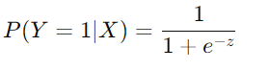
- where z is the linear combination of the predictor variables (e.g., age, gender, treatment type).
- Sigmoid Graph:
  - The y-axis represents the probability of the outcome (e.g., the likelihood of being depressed), ranging from 0 to 1.
  - The x-axis represents the linear combination of predictors or the log-odds.
  - The curve shows that as the predictor variable values change, the probability transitions smoothly between 0 and 1, never reaching exactly 0 or 1 but approaching them asymptotically.
Here’s a typical explanation with a graph to visualize:
- At low values of the predictors (e.g., those who are not at high risk), the probability of the outcome (Depressed = 1) is near 0.
- At higher values of the predictors (e.g., those at higher risk), the probability of the outcome is near 1.
- The middle part of the curve represents cases where the probability is around 0.5, indicating uncertainty or equal likelihood of both outcomes.
Would you like a graph to visualize this?

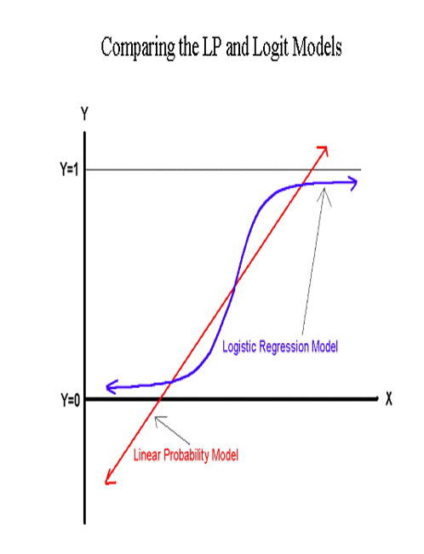

What logistic regression predicts
What is Logistic Regression?
Logistic regression is a statistical method used to predict the probability of an event happening (like an outcome with only two possibilities: yes or no, success or failure).
Key Points:
- Predicting Outcomes:
  - Logistic regression helps us predict whether something will happen or not, based on known factors (independent variables). For example, we might predict whether a person is likely to be diagnosed with a disease (yes or no) based on factors like age, weight, and exercise habits.
- Transforming the Data:
  - In logistic regression, the outcome (yes or no) is transformed into something called the log of the odds (this is also known as the "logit").
  - The odds represent how likely something is to happen compared to not happening.
  - For example, if a doctor says that the odds of getting the disease are 3 to 1, this means it's 3 times more likely to get the disease than not.
- Probabilities and Odds:
  - In the real world, probabilities range between 0 and 1. For example, if there is a 70% chance of rain tomorrow, the probability is 0.7.
  - Logistic regression transforms these probabilities into odds ratios, which can range from 0 to infinity.
  - An odds ratio tells you how much more likely something is to happen compared to it not happening. For example, an odds ratio of 2 means something is twice as likely to occur.
- Cut-off Point:
  - Logistic regression uses a cut-off point to make a prediction. Typically, the cut-off is set at 0.5 (or 50%). If the predicted probability of the event happening is greater than 0.5, we predict that the event will happen. If it’s less than 0.5, we predict the event won’t happen.
  - For example, if a model predicts a 70% chance of rain tomorrow, we would predict that it will rain. If it predicts a 30% chance, we would predict it won’t rain.
Real-Life Example:
Let’s say we want to predict whether a student will pass or fail an exam based on how many hours they studied. The outcome (passing or failing) is binary (yes or no).
- Independent Variable: Hours studied.
- Dependent Variable: Whether the student passed the exam (1 for passed, 0 for failed).
Using logistic regression, we can model the likelihood of passing the exam based on the number of hours studied. The model computes a probability between 0 and 1, and if this probability is higher than 0.5, we predict that the student will pass. If it’s lower than 0.5, we predict that the student will fail.
For instance:
- If the student studied for 2 hours, the model might predict a 30% chance of passing (so we predict they will fail).
- If the student studied for 10 hours, the model might predict a 90% chance of passing (so we predict they will pass).

Logistic regression
1. Logistic Regression and Odds Ratio:
- Logistic Regression is a statistical method used to model the probability of a binary outcome (yes/no, true/false, 1/0). For example, you might want to predict whether a person will buy a product or not based on their age and income.
- Odds Ratio is a key concept in logistic regression. It is defined as the ratio of the probability of an event occurring to the probability of the event not occurring. For instance, the odds of a person buying a product might be 3 to 1, meaning they are three times more likely to buy the product than not to buy it.
Formula for Odds:
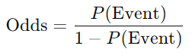
Where P(Event) is the probability of the event happening.
Example: If the probability of buying a product is 0.75, then the odds are:
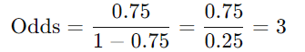
This means the odds of buying the product are 3 to 1 (3 times more likely to buy than not buy).

2. Logarithm of the Odds:
Logistic regression estimates the logarithm of the odds (also known as the log-odds or logit function). Instead of working with probabilities directly, logistic regression models the log of the odds because it converts the nonlinear relationship into a linear form that can be easily worked with.
Why Use Logarithms?
- Probabilities are bound between 0 and 1, but odds can range from 0 to infinity. By taking the logarithm of the odds, we can map the entire range of odds to a scale that ranges from negative infinity to positive infinity, making it easier to model.
Logit Formula:
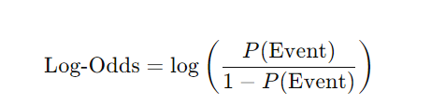
This transforms the relationship into a straight line, making the model easier to interpret.
3. Maximum Likelihood Estimation (MLE):
Logistic regression uses a technique called Maximum Likelihood Estimation (MLE) to estimate the best-fitting model for the data. MLE finds the set of coefficients (the weights on the independent variables) that maximize the likelihood of observing the data given the model.
- MLE adjusts the model parameters so that the predicted probabilities match the actual outcomes as closely as possible.
- Essentially, it chooses the values for the coefficients that make the observed data most likely.
4. Odds Ratio:
The odds ratio provides a way to measure the strength of the relationship between the predictor (independent) variables and the outcome (dependent variable).
- Odds Ratio Definition: It is the ratio of the odds of an event occurring in one group compared to another group.
Example:
- Suppose you are comparing two groups—people who received a particular treatment (Group 1) and people who did not (Group 2). If the odds ratio is 2, it means that people in Group 1 are twice as likely to experience the event (e.g., recovery) as people in Group 2.
5. Estimating the Magnitude of Relationships:
The odds ratio helps estimate how much the independent variables (predictors) affect the likelihood of the event occurring. It tells us:
- How much more or less likely one outcome is compared to another.
- If the odds ratio is greater than 1, it suggests that the event is more likely to occur when the predictor variable increases.
- If the odds ratio is less than 1, it suggests that the event is less likely to occur when the predictor increases.
Example: If you're studying the effect of exercise on heart disease, and the odds ratio is 0.5, it means that people who exercise are half as likely to develop heart disease compared to those who don’t.
6. Examining Effects of Variables:
Logistic regression allows us to examine how the probability of an event (the dependent variable) changes when the independent variable(s) change. It shows how y (the outcome) varies when x (the predictor) varies.
- If you increase the value of the independent variable (like the number of hours studied for an exam), logistic regression helps you see how the probability of passing the exam changes.
- This is useful when studying relationships between variables like:
  - Age and the likelihood of having a disease.
  - Income and the likelihood of purchasing a product.
  - Education level and the likelihood of getting a promotion.

Conclusion:
- Logistic regression is a powerful tool for understanding the relationship between one or more independent variables and a binary outcome. It uses odds ratios and MLE to model the probability of an event happening, making it especially useful in fields like health research, marketing, and social sciences. The key insight provided by logistic regression is how the probability of the outcome changes as the predictor variables change.

Logistic regression model description
This is the logistic function. It is a type of sigmoid function, which is S-shaped and maps any real number y to a value between 0 and 1. The function is widely used in logistic regression to model probabilities, where the output f(y) represents the probability of an event occurring. The input y is usually a linear combination of the predictors (features).

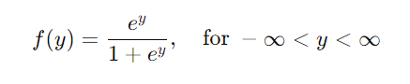
- For very large negative values of y, f(y) approaches 0.
- For very large positive values of y, f(y) approaches 1.

2. Graph of the Logistic Function:
The second image shows the graph of the logistic function $\frac{e^{y}}{1+e^{y}}$ as a function of y
- The x-axis represents the values of y.
- The y-axis shows the output of the logistic function, ranging from 0 to 1.
Key points:
- When y=0, f(y)= $\frac{e^{0}}{1+e^{0}}$ =0.5. this is where curve crosses the midpoint
- As y becomes very negative, the function approaches 0, and as y becomes very positive, it approaches 1, creating the characteristic "S" shape.

Relation to Logistic Regression:
- In logistic regression, this logistic function is applied to the output of a linear model to predict the probability of a binary outcome (0 or 1). The probability output can be used to classify an observation into one of two categories based on a threshold (commonly 0.5).
- In summary, these slides show how the logistic function transforms a linear model's output into a probability, which is the foundation of logistic regression.
Logistic Regression Overview
- Model Equation:
  - The logistic function models the probability of an outcome (like churn) using a linear combination of input variables (like age, contacts, etc.).
  - The linear equation for logistic regression is:
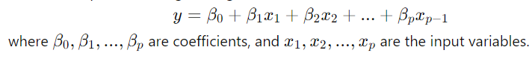
Logistic Function:
- After calculating y, the logistic function is applied to convert y into a probability

This transforms the linear equation into a probability ranging between 0 and 1.
Log Odds (Logit):
- The log odds (or "logit") of the probability p is given by:
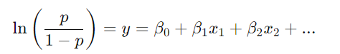
This formula can be used to understand the linear relationship between variables and the log odds of the outcome (in this case, customer churn).
Parameter Estimation:
- Maximum Likelihood Estimation (MLE) is used to estimate the model parameters (the coefficients β0,β1,...,βp).
Customer Churn Example:
The second part of the slides gives an example of using logistic regression to predict customer churn (whether a customer will leave or stay).
- Variables:
  - The model uses variables like age (in years), churned contacts (the number of previous companies the customer has left), marital status, and duration as a customer.
- Regression Equation:
  - After analyzing the data, the model selected age and churned contacts as the most important variables. The resulting equation for predicting churn is:
- Here, y is a linear combination of age and churned contacts. This value is then passed through the logistic function to compute the probability of a customer churning.
- Customer Churn Probabilities:
  - A table lists various customers with their age, churned contacts, the calculated y-value, and the probability of churning (converted from y using the logistic function).
  - For example, a customer aged 50 with 1 churned contact has a y-value of -4.12 and a churn probability of 0.016 (1.6% chance of leaving).
  - Another customer aged 20 with 6 churned contacts has a y-value of 2.58 and a churn probability of 0.930 (93% chance of leaving).

Key Takeaways:
- Logistic regression is used to predict the probability of a binary outcome (such as churn or not).
- It uses a logistic function to map a linear combination of input variables into a probability between 0 and 1.
- In this customer churn example, age and churned contacts were found to be the best predictors of whether a customer will leave the company.

